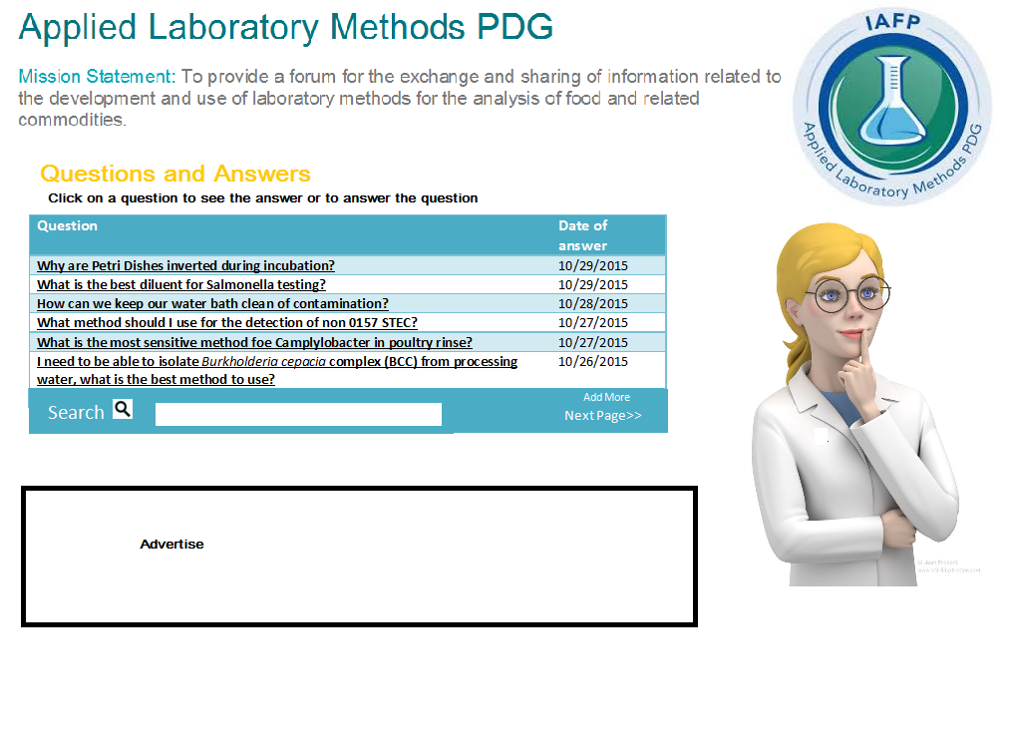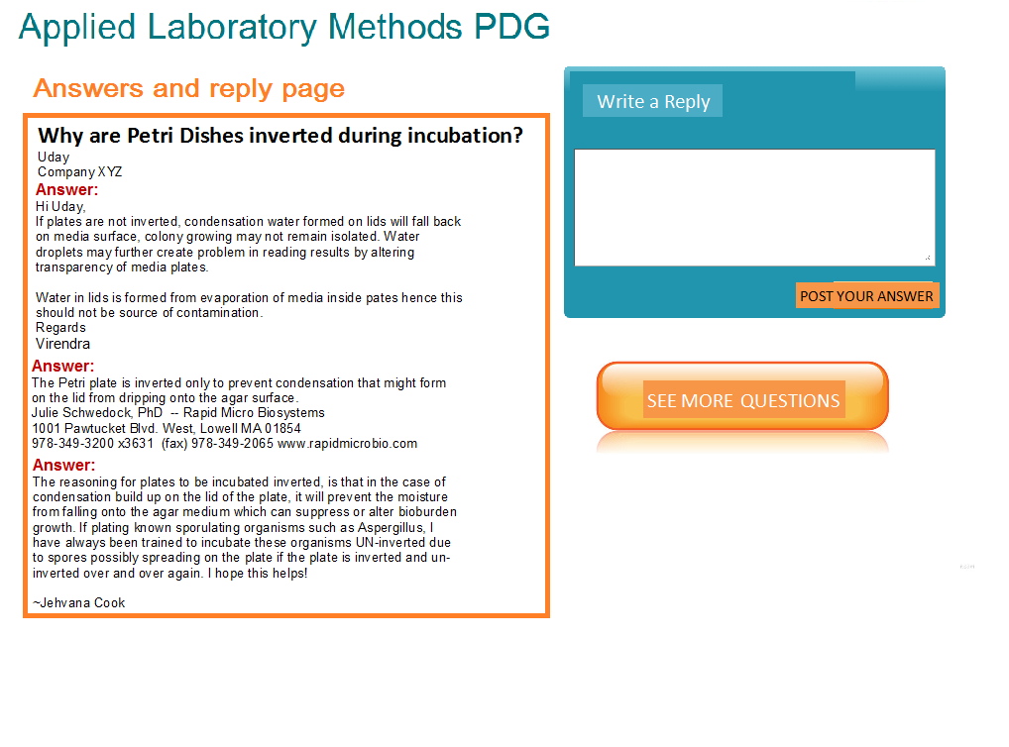

# C:\Users\Ruth\AppData\Local\Microsoft\Windows\INetCache\Content.Word\Dairy.jpgDairy Quality & Safety Professional Development Group

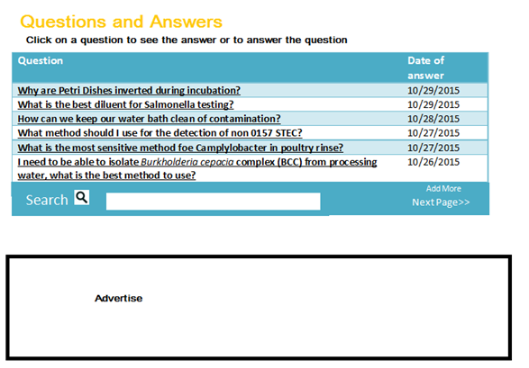**Mission Statement:** To promote the production and processing of safe, high quality dairy products and to develop program topics and symposia for presentation at the IAFP Annual Meetings.

**Dairy Quality & Safety PDG**

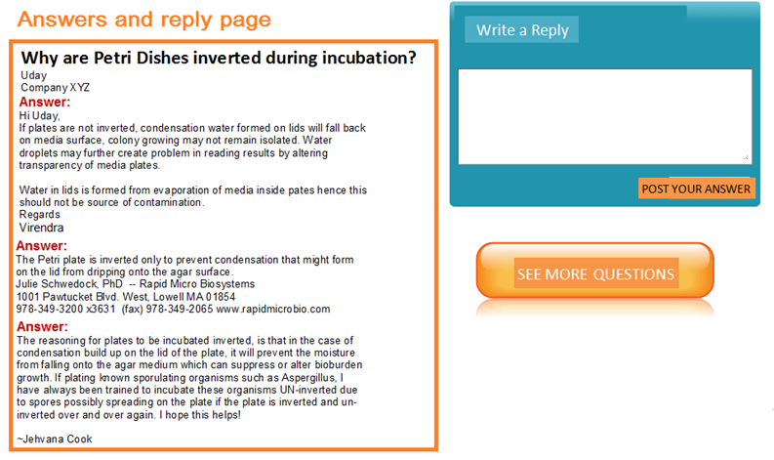

# Beverages and Acid/Acidified Foods Professional Development Group



**Mission Statement:** To provide a forum to discuss and develop symposia on issues facing the beverages and acid/acidified foods industry.



**Beverages and Acid/Acidified Foods PDG**



Advanced Molecular Analytics



Professional Development Group

Mission Statement: To provide a forum for the exchange and sharing of information related to the development and use of advanced and emergent technologies to promote food safety and public health



Advanced Molecular Analytics PDG



# Food Law Professional Development Group

**Mission Statement:** To provide an international forum for the exchange of information on the scientific issues associated with food laws, regulations and policy.

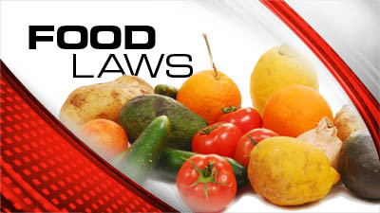

**Food Law PDG**

# Fruit and Vegetable Safety and Quality Professional Development Group

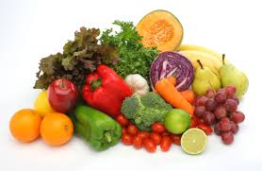

**Mission Statement:** To provide a forum to discuss items of interest to the safe production of fruit and vegetable products and to develop program topics and symposia for presentation at the IAFP Annual Meetings.



**Fruit and Vegetable Safety and Quality**



# Food Safety Education Professional Development Group



**Mission Statement:** To provide IAFP Members and their clientele information on food safety education.



**Food Safety Education PDG**

